Jewelia England

CS 255 Project Two

CS 255 System Design Document Template

UML Use Case Diagram

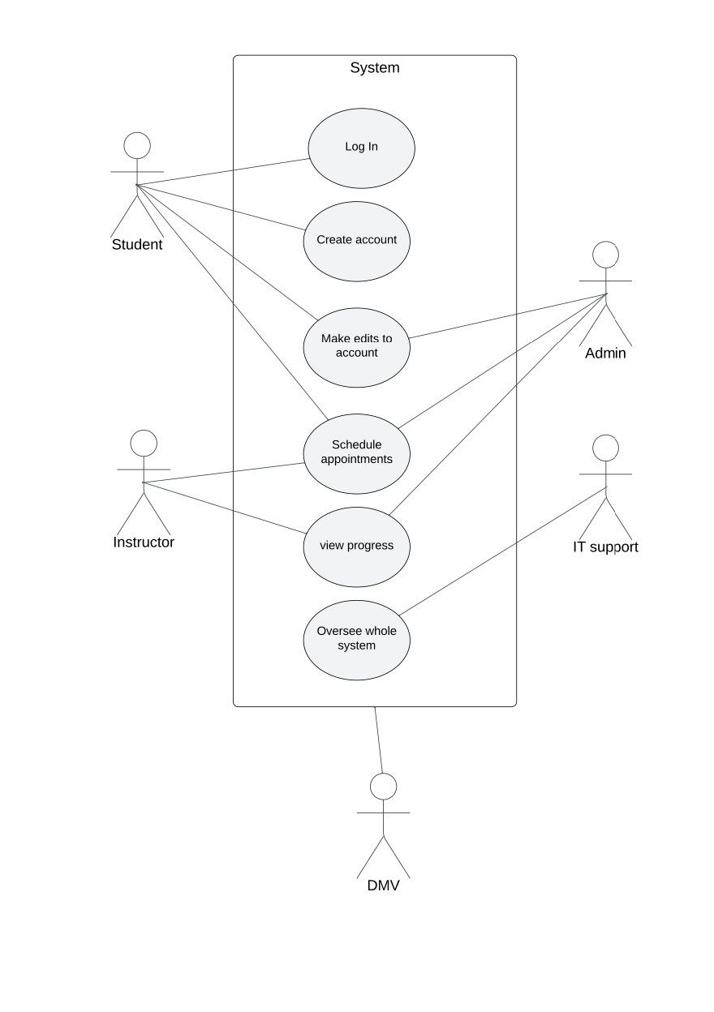

UML Activity Diagrams

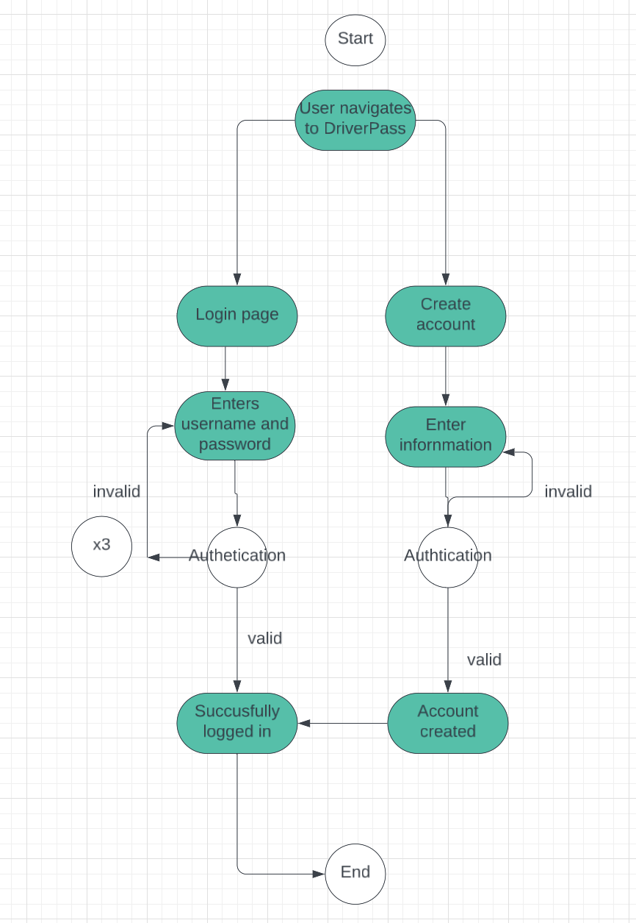

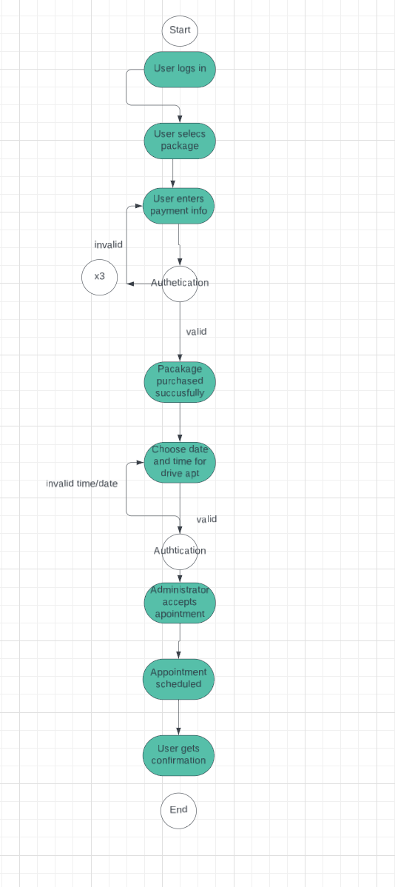

UML Sequence Diagram

*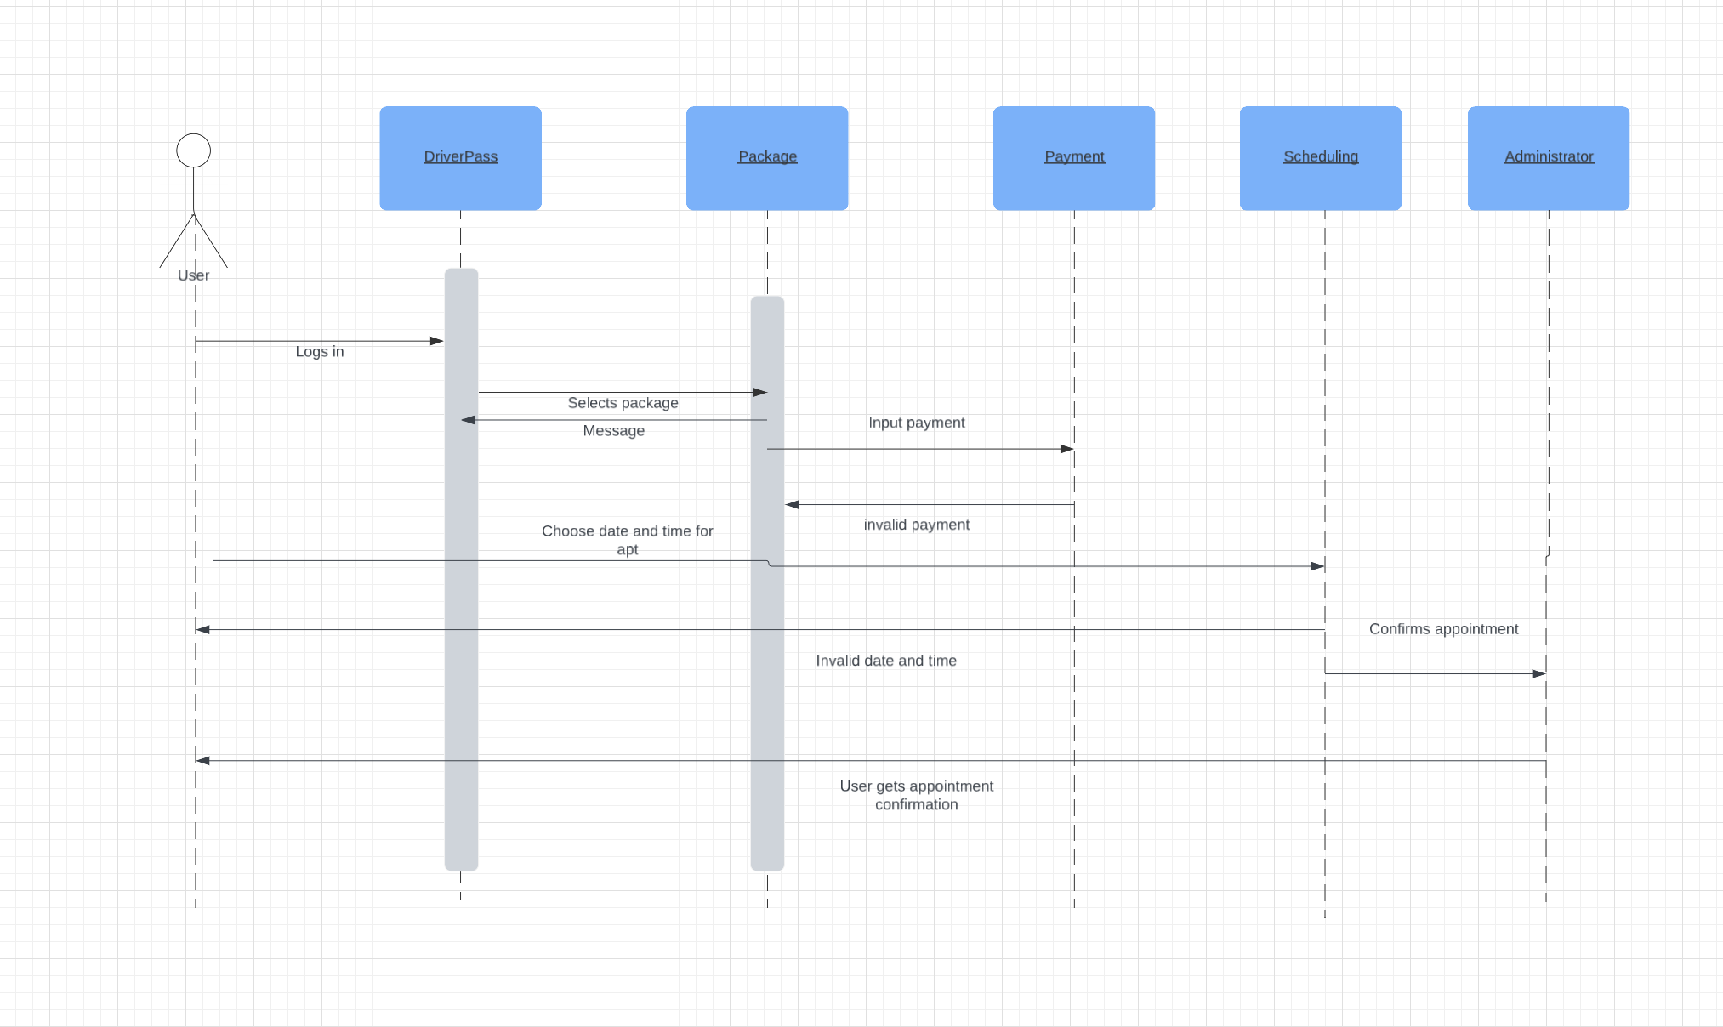*

UML Class Diagram

*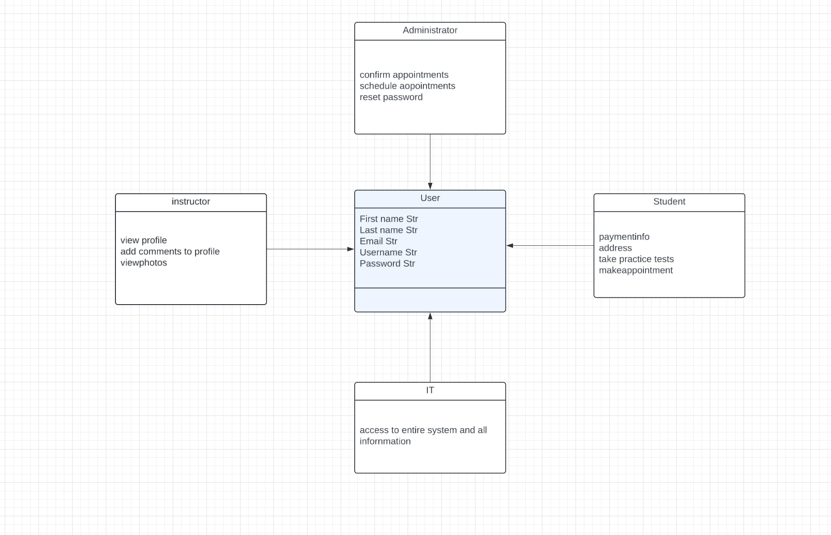*

Technical Requirements

* Internet connection
* Computer
* Ensured security to protect user info
* Validate login
* Reset a password
* Validate payment